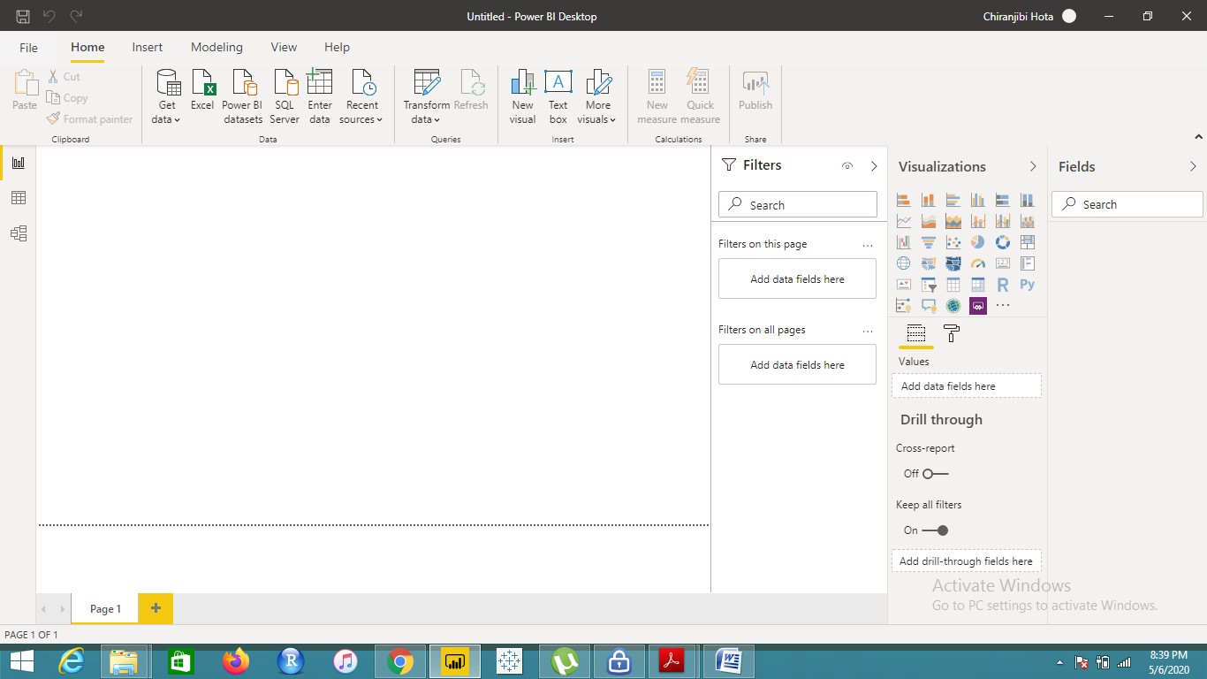

**Report View**

This is the panel where we can create reports and graphs using our data.



**Data View**

Here we can view the data that has been imported.

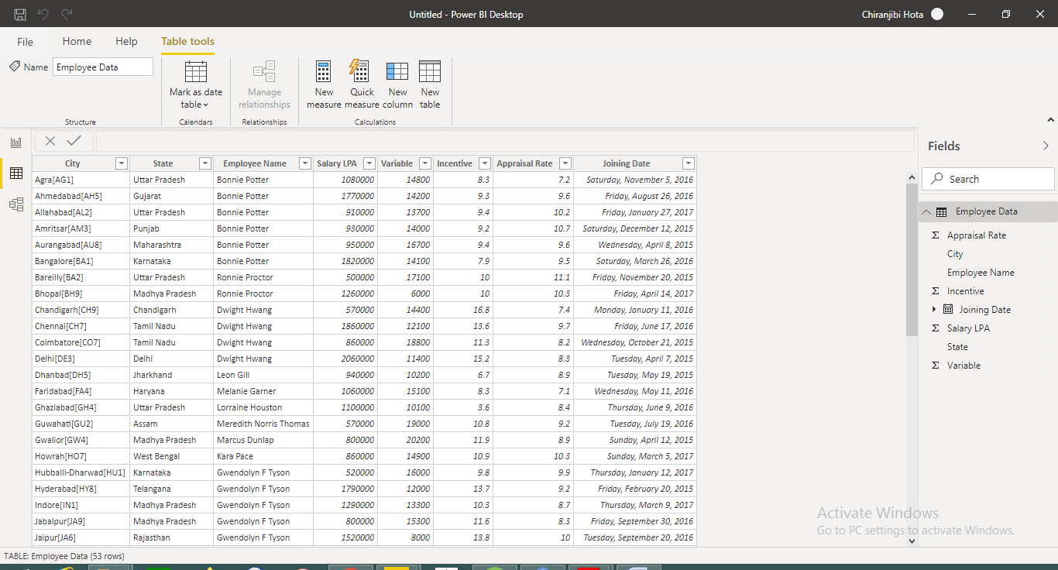

**Model View**

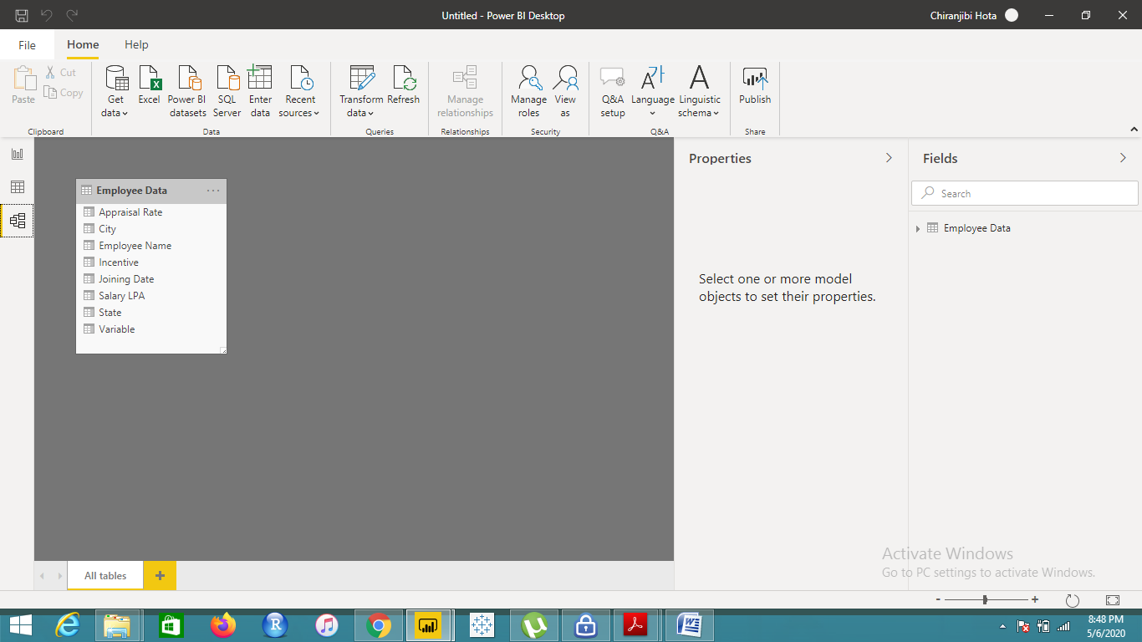

**Power Query Editor**

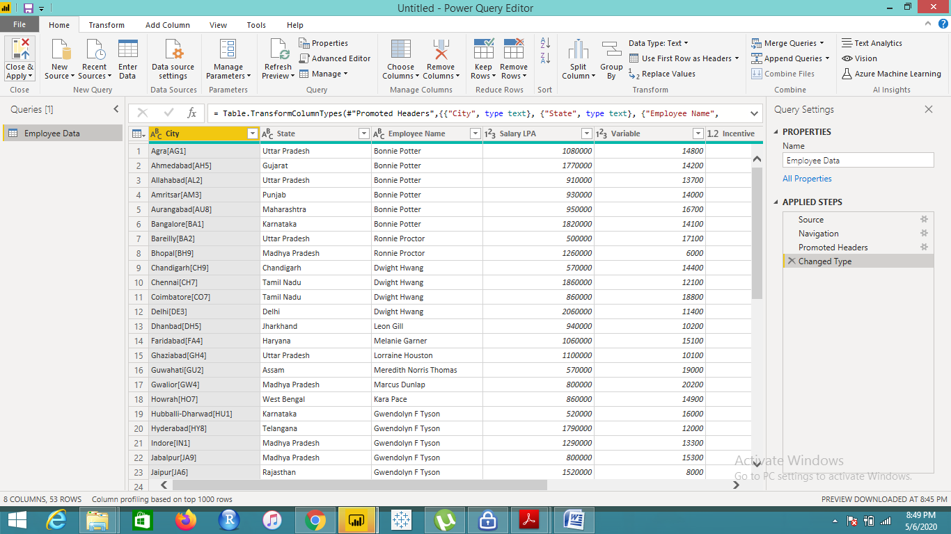

**Advanced Editor**

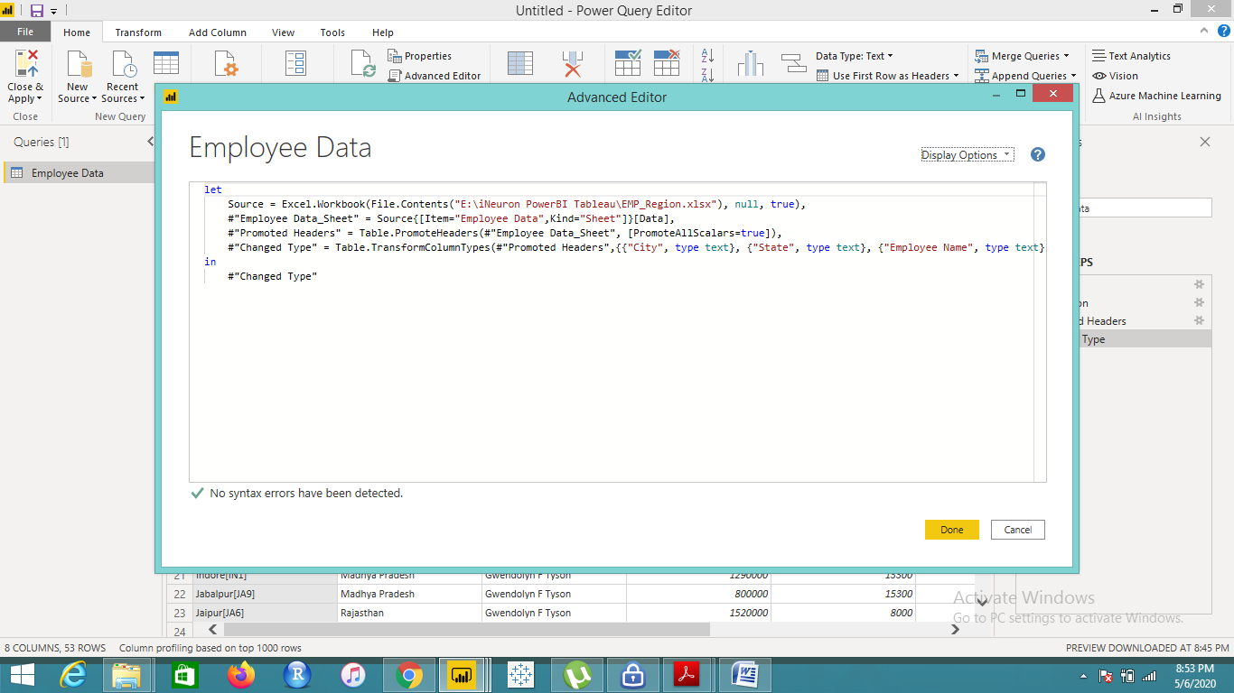

**Power BI Desktop**

* On-premise solution that connects to a cloud-based service to easily upload and share data and information across the company.
* Price- Free of cost

**Power BI Pro**

* Self-service and modern BI in the cloud
* Collaboration, publishing, sharing, and ad-hoc analysis
* Fully managed by Microsoft
* Price – 9.99$ (monthly/user)

**Power BI Premium**

* Enterprise BI, big data analytics, cloud and on-premises reporting
* Advanced administration and deployment controls
* Dedicated cloud compute and storage resources
* Allows any user to consume Power BI content
* Price- $4,995(Monthly price per dedicated cloud compute and storage resource with annual subscription)